OS8 Equipment Development
and Testing Plan

Operating Unit：Iovtec Co. Ltd

2026/07/10

Contents
I. Purpose and Scope of the Plan 4
1. Objectives 4
2. Equipment Testing Period 4
3. Scope of Equipment Testing 4
II. Vessel Information 6
1. Vessel Information 6
III. List of Testing Instruments 8
1. List of Testing Instruments 8
IV. Schematic Diagram of Testing Operations 10
V. Route Planning 11
VI. Contact Information 11

Table of Contents
Table 1. Corner Coordinates of the Testing Area 5
Table 2. Specifications of Ocean Surveyor No. 8 6
Table 3. Specifications of Ocean Surveyor No. 9 7
Table 4. List of Testing Instruments 8
Table 5. Specifications of GAVIA Underwater Vehicle 9

List of Figure
Figure 1. Schematic Diagram of the Testing Area 4

I. Purpose and Scope of the Plan
- Objectives
Our company’s work vessel, Ocean Surveyor 8, will conduct marine survey and underwater equipment calibration operations in the waters southwest of Taiwan.

- Equipment Testing Period
The equipment testing period is from August 1, 2026 to September 15, 2026

- Scope of Equipment Testing
Vehicle operation testing will be conducted in the waters southwest of Taiwan. To ensure navigational safety, the Ocean Surveyor No. 8 and Ocean Surveyor No. 9 will be selected for operation. The home port for equipment testing is Xingda Port, with Kaohsiung Port designated as the backup port.
The expected testing area is shown in Figure 1, and the coordinates of the corner points of the testing area are listed in Table 1.

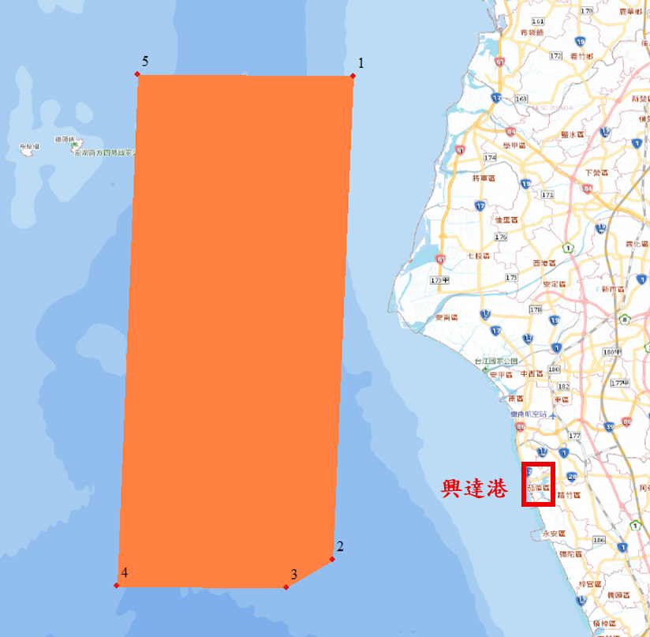
Figure 1. Schematic Diagram of the Testing Area
Table 1. Corner Coordinates of the Testing Area
No. | X Coordinate  (TWD97) | Y Coordinate  (TWD97) | Longitude  (WGS84,DMS) | Latitude  (WGS84,DMS)
1 | 146465.234 | 2581867.889 | 119° 59' 15.1358" E | 23° 20' 10.0980" N
2 | 143619.588 | 2520826.941 | 119° 57' 50.1898" E | 22° 47' 05.3030" N
3 | 138183.524 | 2517367.605 | 119° 54' 40.5135" E | 22° 45' 11.5857" N
4 | 118320.005 | 2517668.767 | 119° 43' 04.2731" E | 22° 45' 16.2074" N
5 | 121330.751 | 2582244.610 | 119° 44' 30.3288" E | 23° 20' 15.9288" N

II. Vessel Information

Vessel Information
The testing plan will use Ocean Surveyor No. 8, while Ocean Surveyor No. 9 will serve as the backup vessel. Their specifications are shown in Table 2 and Table 3.
Table 2. Specifications of Ocean Surveyor No. 8
Vessel Information
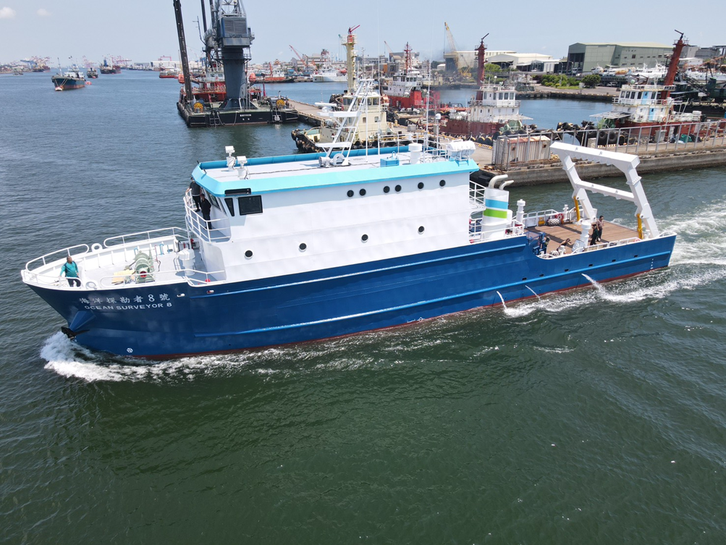
Vessel Name | Ocean Surveyor No.8
Home Port | Kaoshiung Port
Gross Tonnage | 326
LOA | 36.00 m
Width | 7.40 m
Call sign | BR5137
MMSI | 416013942
Table 3. Specifications of Ocean Surveyor No. 9
Vessel Information
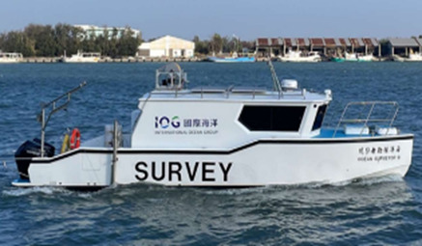
Vessel Name | Ocean Surveyor No.9
Home Port | An Ping Port
Gross Tonnage | 14.17
LOA | 13.25m
Width | 2.98m
Call sign | BR4920
MMSI | 416009799

III. List of Testing Instruments

List of Testing Instruments
The testing instruments for this project are provided by International Ocean Co. The list of testing instruments is shown in Table 4, and the specifications are presented in Table 5 and Table 6.
Table 4. List of Testing Instruments
No. | Instrument Category | Instrument Name | Vessel Used
1 | Underwater Vehicle | GAVIA | OS8.OS9

Table 5. Specifications of GAVIA Underwater Vehicle
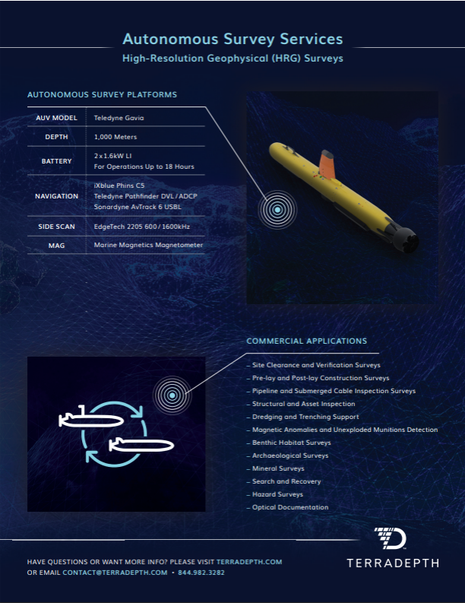

IV. Schematic Diagram of Testing Operations
The operational schematic of Ocean Surveyor No. 8, Ocean Surveyor No. 9, the surface vehicle, and the underwater vehicle are shown below.
In principle, the operating depth of the underwater vehicle is maintained at least 25 meters above the seabed. For example, when the water depth is 60 meters, the maximum operating depth is approximately 35 meters; when the water depth is 100 meters, the maximum operating depth is approximately 75 meters.
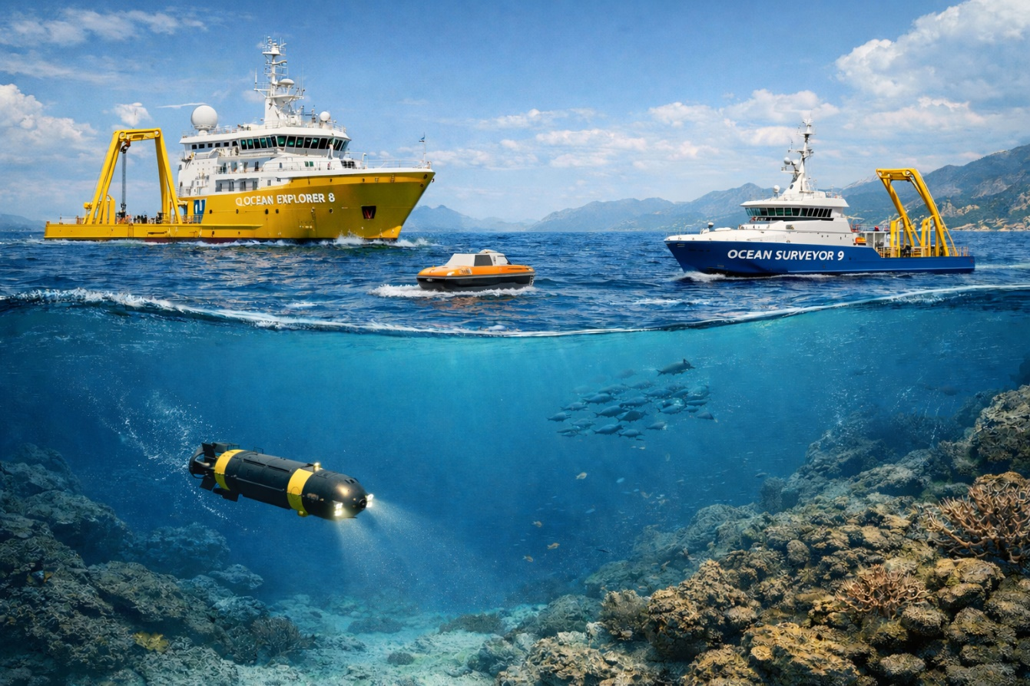

V. Route Planning
The vessel will depart from Xingda Port and proceed northwest to the designated operation area. Upon completion of the operation, the vessel will return to Xingda Port. The operation area is shown in Figure 1.

VI. Contact Information
Position | Company | Name | Mobile Phone
Survey Package Manager | IOVTEC Co., Ltd. | 張祐銓 | +886 953-310-315
Project Manager | IOVTEC Co., Ltd. | 周千又 | +886 989-701-969

